**Lab 7**

Link for assignment **:** <https://github.com/Diya-Lad/SDP>

There are 2 types of widgets:

1) Stateless: Widget whose state we can’t change

2) Stateful: Widget whose state we can change

* To add stateless widget short cut is stless and for stateful widget is stful.
* To add Any static data like font, Image we can use pubspec.yaml file.

Code test : 1 : Images

void main() {  
 runApp(MaterialApp(  
 home: HomeScreen()  
 ));  
}  
  
class HomeScreen extends StatelessWidget {  
// const test1({Key? key}) : super(key: key);  
  
 @override  
 Widget build(BuildContext context) {  
 return Scaffold(  
 appBar: AppBar(  
 title: Text('HELLO FLUTTER...MY FIRST APP'),  
 centerTitle: true,  
 backgroundColor: Colors.*red*[600],  
 ),  
 body: Center(  
 child: Image(  
 image: AssetImage('asset/img.jpg'),  
 )  
 ),  
 floatingActionButton: FloatingActionButton(  
 onPressed: () {},  
 child: Text('Click'),  
 backgroundColor: Colors.*red*[600],  
 ),  
 );  
 }  
}

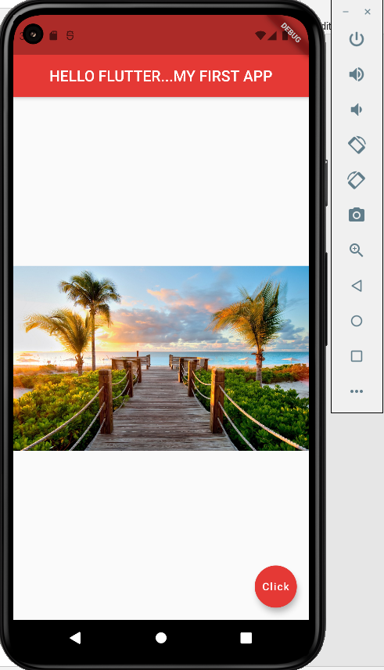

Code test 2: Icon

body: Center(  
 child: Icon(  
 Icons.*add_reaction*,  
 color: Colors.*red*,  
 size: 300.0,  
 ),  
),

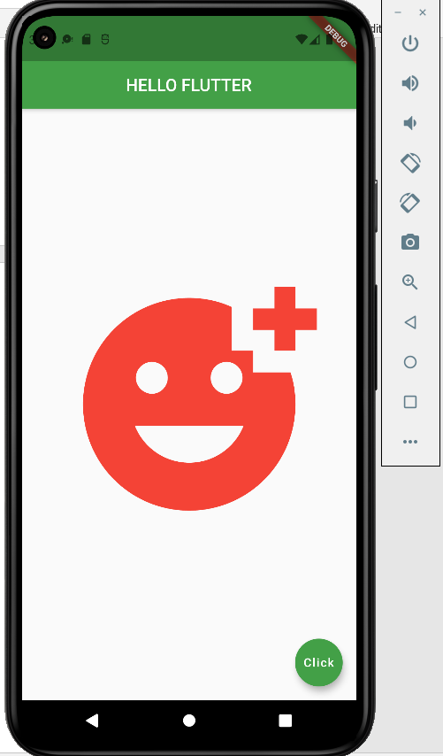

**code test 3 : Buttons**

body :Center(  
 child: ElevatedButton(  
 child: Text('Button'),  
 onPressed: () {},  
 style: ElevatedButton.*styleFrom*(  
 primary: Colors.*pink*[800],  
 padding: EdgeInsets.symmetric(horizontal: 50, vertical: 20),  
 textStyle: TextStyle(  
 fontSize: 40,  
 fontWeight: FontWeight.*bold*)),  
 ),  
),

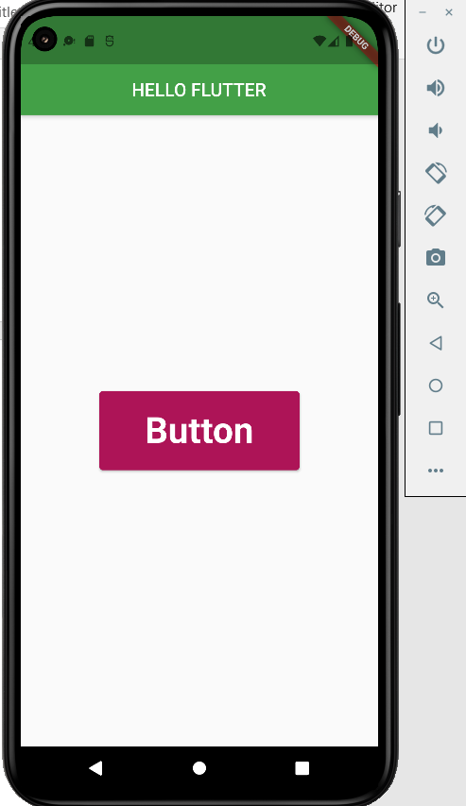

body:Center(  
 child: FlatButton(  
 onPressed: () {  
 print('print on consol');  
 },  
 child: Text('click Me', style: TextStyle(  
 fontSize: 20.0  
 ),),  
 color: Colors.*yellow*,  
 )  
),

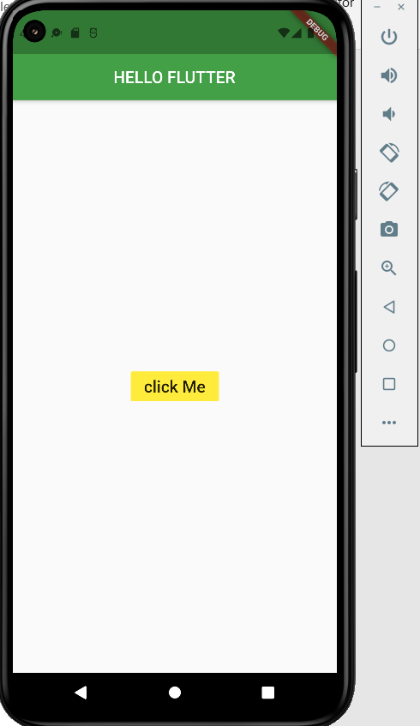

body: Center(  
 child: IconButton(  
 icon: Icon(  
 Icons.*animation*,  
 color: Colors.*green*,  
 size: 50.0,  
 ),  
 tooltip: 'Animation',  
 onPressed: () {  
 print('Hello World');  
 },  
 ),  
)

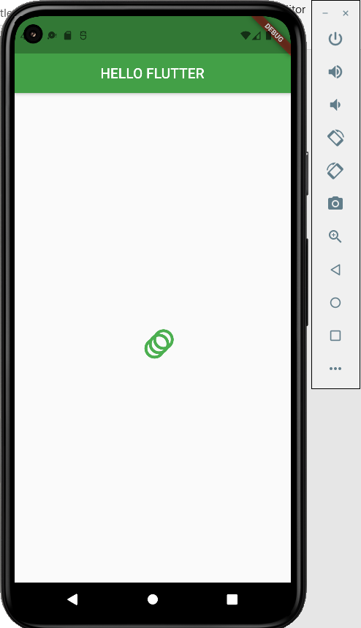

body: Center(  
 child: TextButton.icon(  
 icon: Icon(  
 Icons.*photo_camera*,  
 color:Colors.*grey*,  
 size: 50.0,  
 ),  
 label: Text("Gallery",style: TextStyle(  
 color: Colors.*black*,  
 fontSize: 40.0,  
 letterSpacing: 2.0,  
 ),  
 textAlign: TextAlign.start,  
 ),  
 onPressed: () {},  
 )  
),

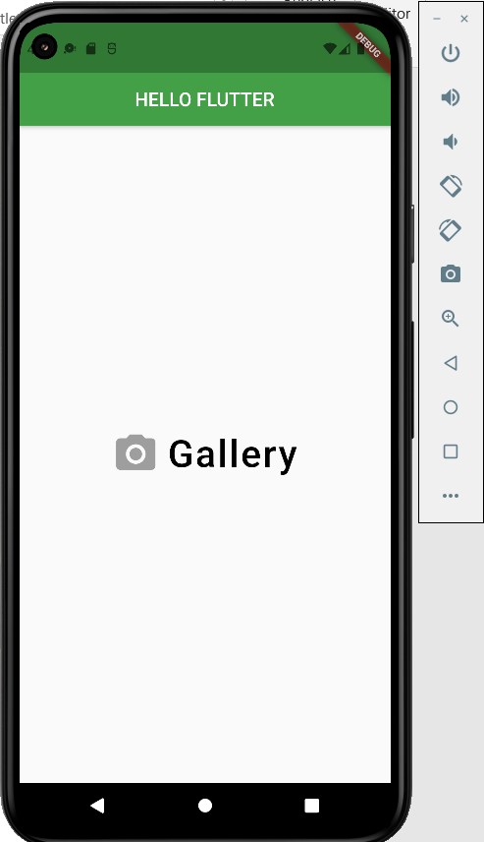

body: Center(  
 child: Directionality(  
 textDirection: TextDirection.rtl,  
 child: TextButton.icon(  
 icon: Icon(  
 Icons.*photo_camera*,  
 color:Colors.*grey*,  
 size: 40.0,  
 ),  
 label: Text("Gallery", style: TextStyle(  
 color: Colors.*black*,  
 fontSize: 40.0,  
 letterSpacing: 2.0,  
 ),  
 textAlign: TextAlign.start,  
 ),  
 onPressed: () {},  
 ),  
 )  
),

Here we have use direction rtl means right to left so 1st component will be on right and 2nd will be on left direction means direction is reversed.

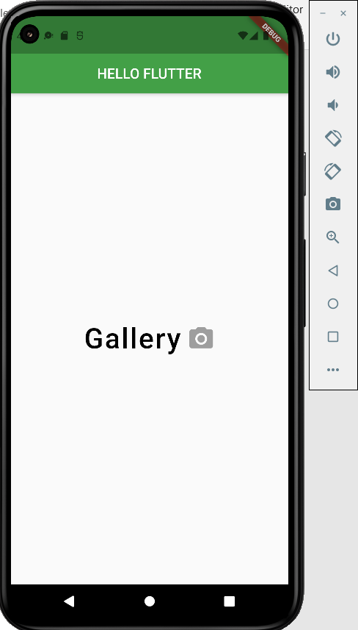

body: Column(  
 children: [  
 Container(  
 child: ElevatedButton(  
 child: Text('Button'),  
 onPressed: () {},  
 style: ElevatedButton.*styleFrom*(  
 primary: Colors.*pink*[800],  
 padding: EdgeInsets.symmetric(horizontal: 50, vertical: 20),  
 textStyle: TextStyle(  
 fontSize: 40,  
 fontWeight: FontWeight.*bold*)),  
 ),  
 ),  
 Container(  
 child: FlatButton(  
 onPressed: () {  
 print('print on consol');  
 },  
 child: Text('click Me'),  
 color: Colors.*blue*,  
 )  
 ),  
 Container(  
 child: IconButton(  
 icon: Icon(  
 Icons.*animation*,  
 color: Colors.*green*,  
 size: 50.0,  
 ),  
 tooltip: 'Animation',  
 onPressed: () {  
 print('Hello World');  
 },  
 ),  
 ),  
 Container(  
 child: TextButton.icon(  
 icon: Icon(  
 Icons.*photo_camera*,  
 color:Colors.*grey*,  
 size: 50.0,  
 ),  
 label: Text("Gallery",style: TextStyle(  
 color: Colors.*black*,  
 fontSize: 40.0,  
 letterSpacing: 2.0,  
 ),  
 textAlign: TextAlign.start,  
 ),  
 onPressed: () {},  
 )  
 ),  
 Container(  
 child: Directionality(  
 textDirection: TextDirection.rtl,  
 child: TextButton.icon(  
 icon: Icon(  
 Icons.*photo_camera*,  
 color:Colors.*grey*,  
 size: 40.0,  
 ),  
 label: Text("Gallery", style: TextStyle(  
 color: Colors.*black*,  
 fontSize: 40.0,  
 letterSpacing: 2.0,  
 ),  
 textAlign: TextAlign.start,  
 ),  
 onPressed: () {},  
 ),  
 )  
 )  
 ],

)

